**Jenkins Declarative Script**

Jenkins path location in linux

/var/lib/Jenkins/workspace

go to Jenkins

Manage Jenkins—Manage plugin— search for pipeline – install

now create new job – name the job and select pipeline

now go to pipeline tab and write the declarative script in the below formate

pipeline {

    agent any

    environment {

        PATH = "/opt/apache/bin:$PATH"

        }

        stages

            stage('git') {

                steps {

                    git url: 'https://github.com.git'

                }

            }

        stage('build') {

            steps {

                sh 'mvn clean install'

            }

        }

        stage('deploy') {

            steps {

                sshagent(['deploy_user']) {

                    scp webapp/target/webapp.war ec2-user@13.229.183.126: /opt/apache-tomcat-8.5.55/webapp

                }

            }

        }

}

**git**

for cloning git we new to use pipeline syntax tool which is in the bottom of the page

in pipeline syntax need to select git and provide repo url, branch , credentials

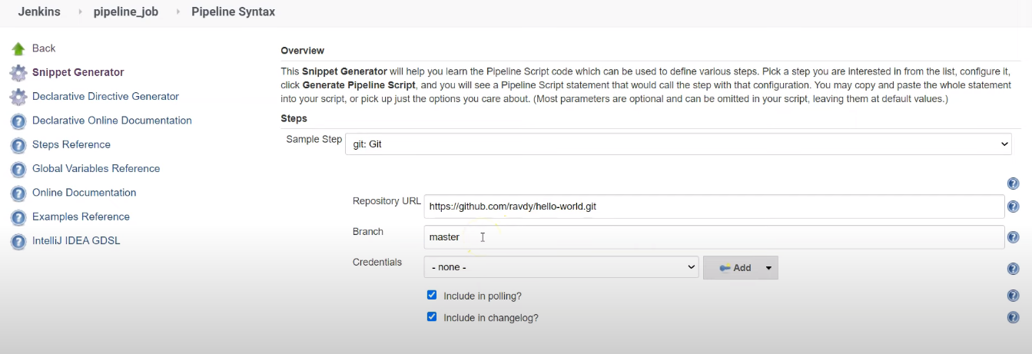

        stages

            stage('git') {

                steps {

                    git url: 'https://github.com.git'

                }

            }

**Maven**

        stage('build') {

            steps {

                sh 'mvn clean install'

            }

        }

copying war file to tomcat server to slave machine with ssh agent

here we need to go pipeline syntax and select SSH Agent and add the credentials as shown below

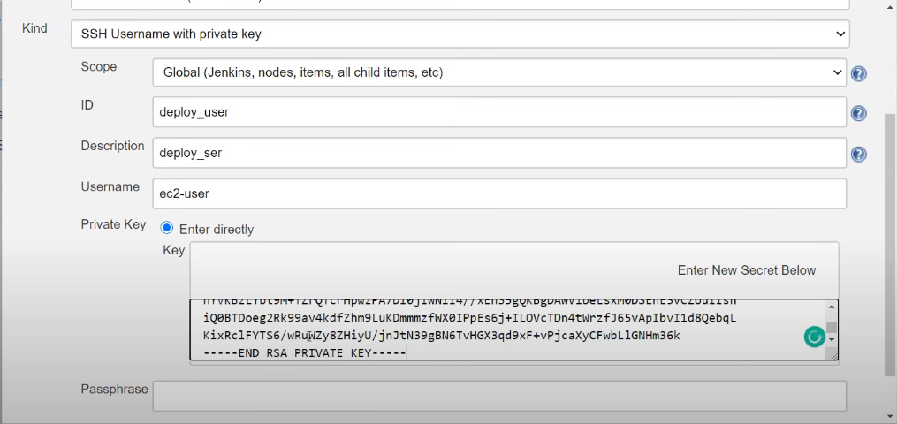

and select the specific user and generate pipeline script and copy the code and add in script

stage('deploy') {

            steps {

                sshagent(['deploy_user']) {

                    scp webapp/target/webapp.war ec2-user@13.229.183.126: /opt/apache-tomcat-8.5.55/webapp

                }

            }

        }

scp <src_file> username@IP: <Dest_path>

here scp is copying file from one server to another slave machine(tomcat server)